**Experiment Procedure Documentation**

**Introduction**

This document captures the instructions to run the simulation.

**Instructions**

1.To run the experiment, simply run the exp.html file by clicking on it and the experiment will open in the browser.

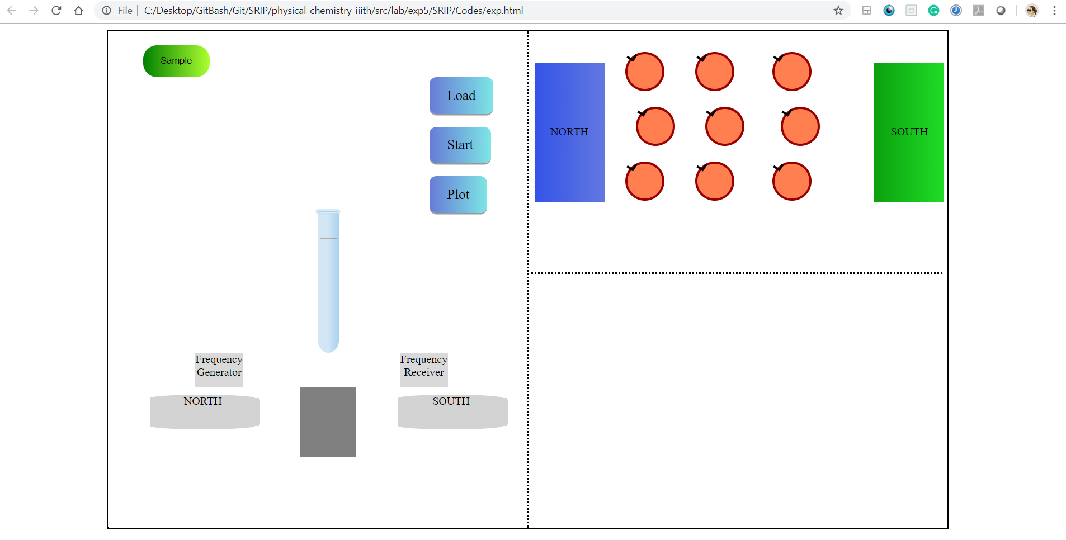

2.To run the experiment ,click the “Sample” button. On clicking it, 3 options,namely Benzene,Acetaldehyde and Ethyl acetate will appear as a drop down menu.Select one option according to your choice.

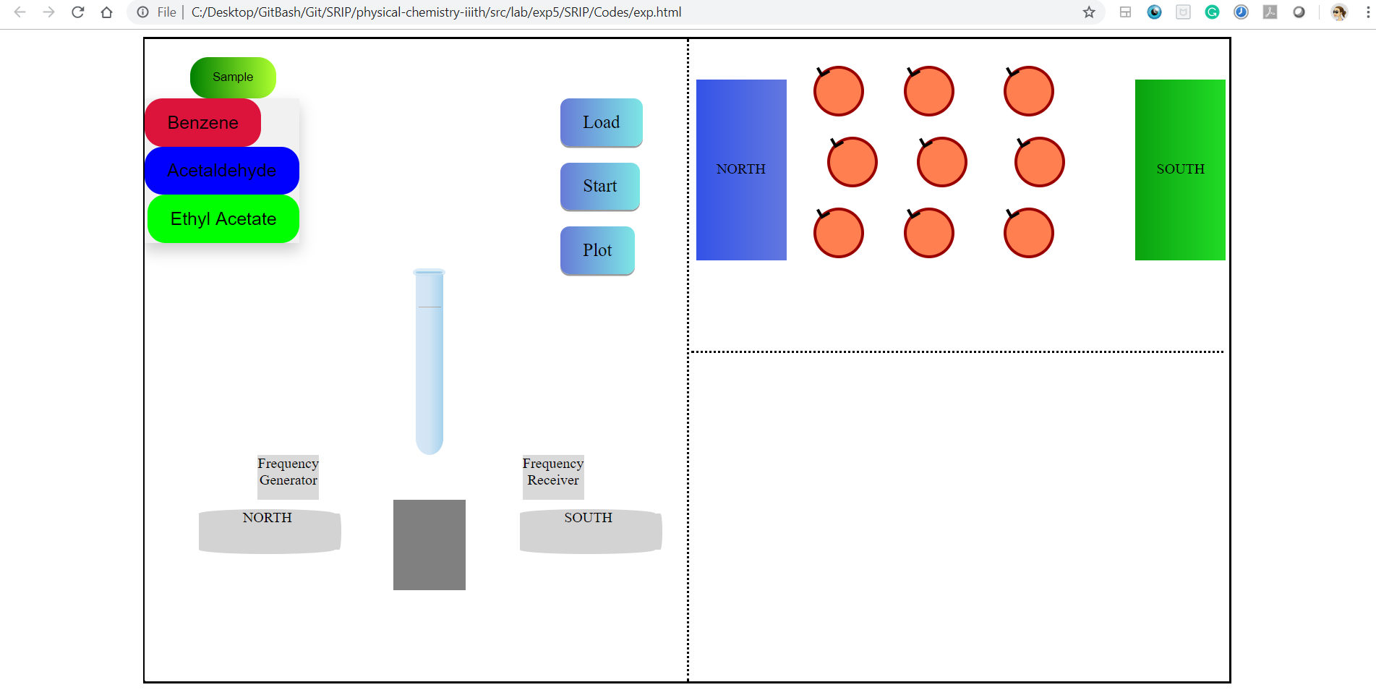

3.Now,click on the “Load ” button to load the sample .

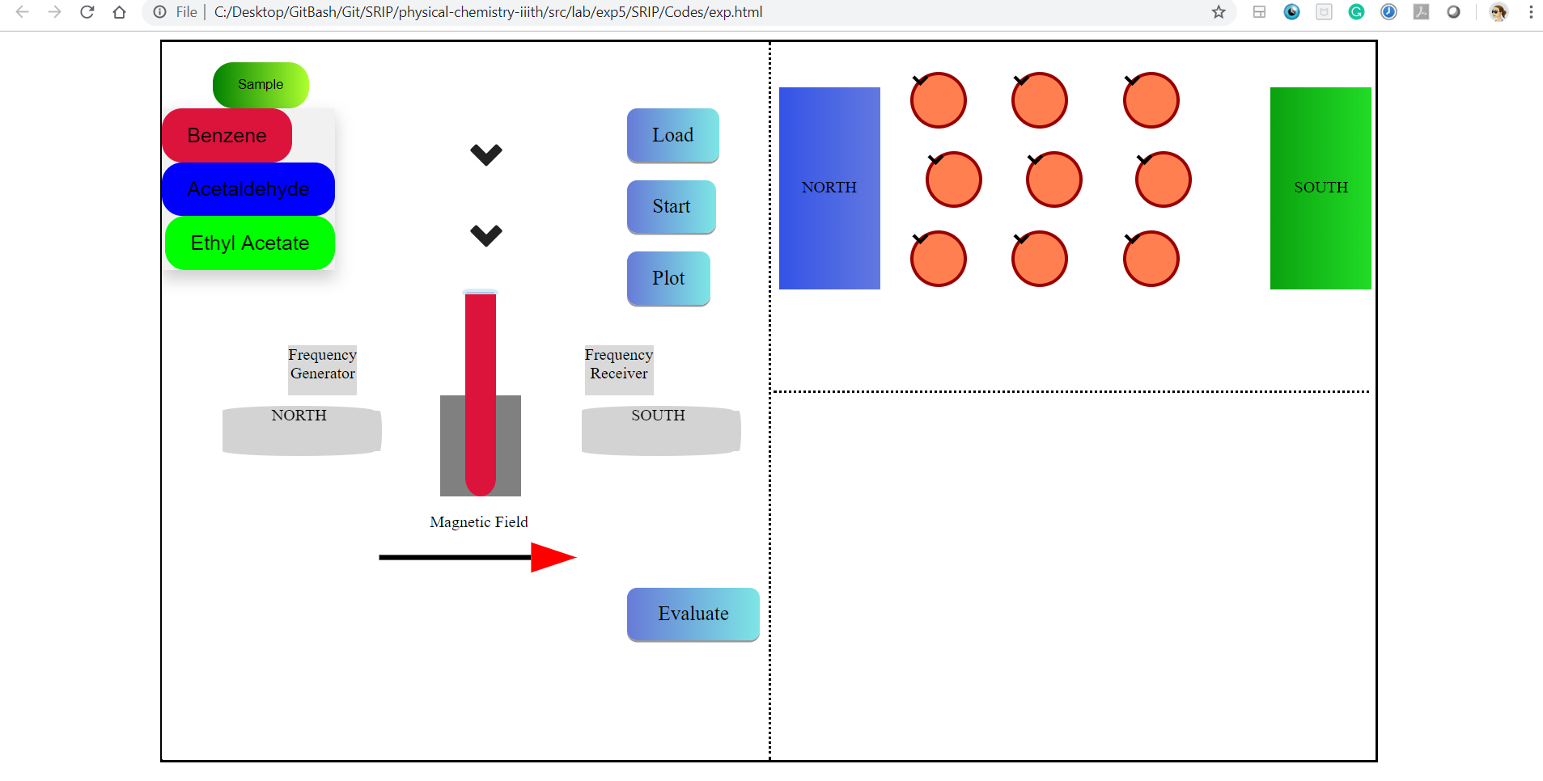

4.Click the “Start” button to start the experiment.

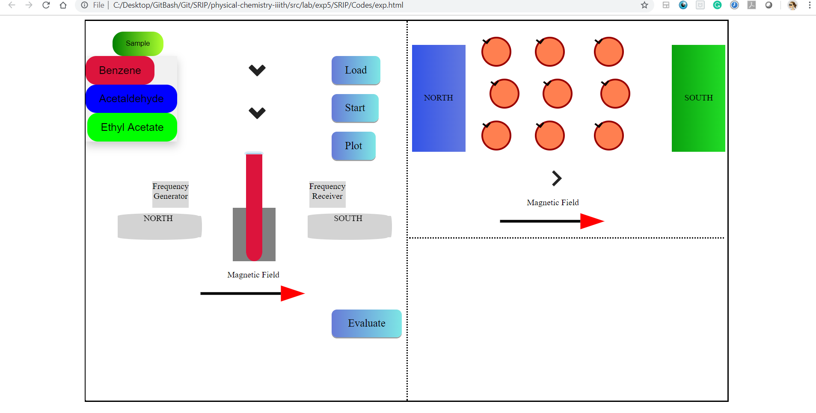

5.After clicking on the ‘Start’ button, click the “Plot” button in order to see the Intensity Graph.

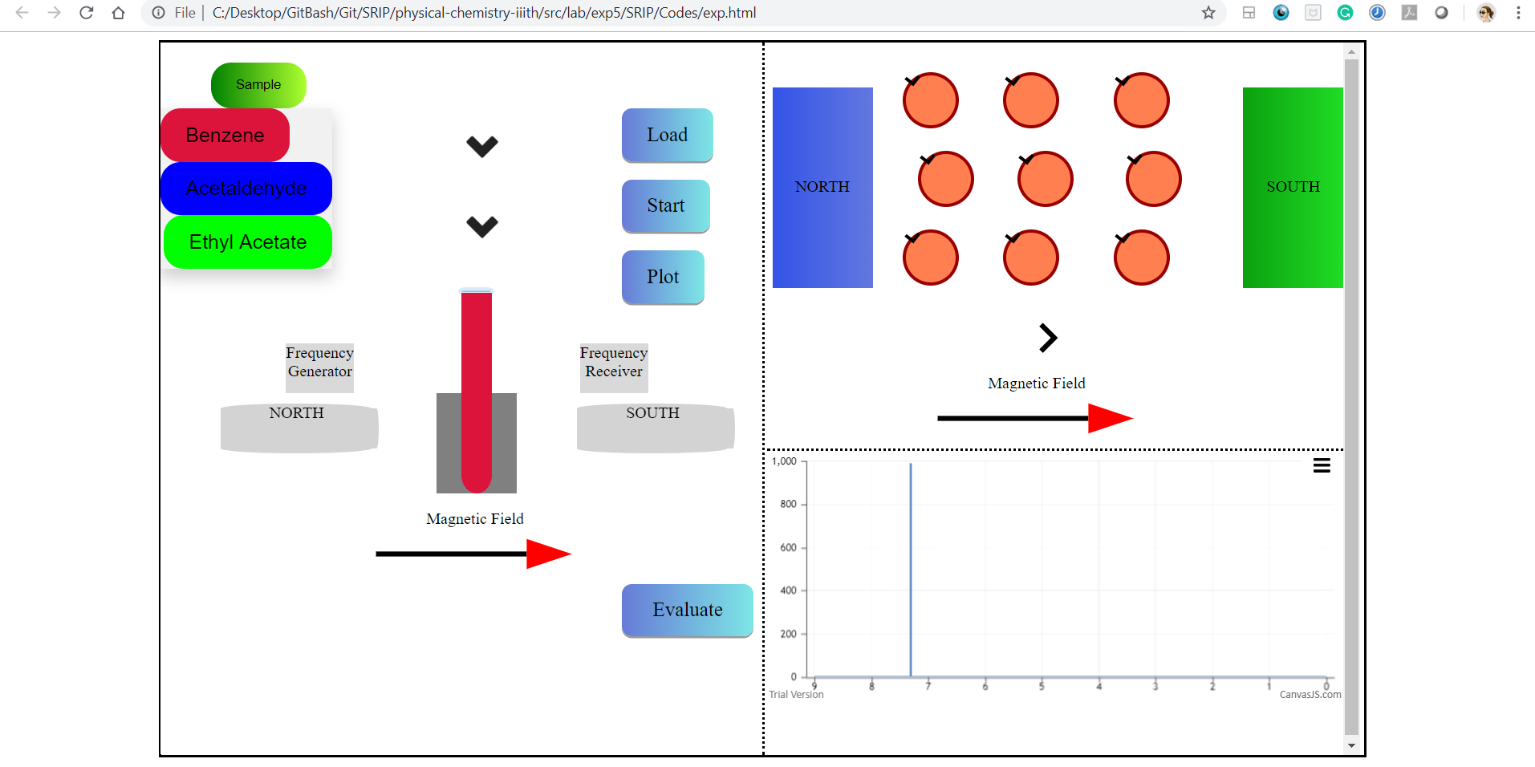

Here,the plot is displayed according to the option chosen.

6.On clicking the “Evaluate” button,you are redirected to another page where the Intensity graph will be displayed along with a small questionnaire